**Background:**

* 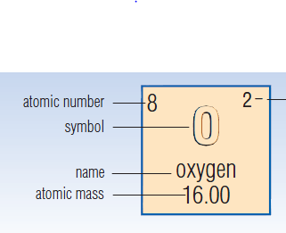All elements known to Science and Chemistry are listed on the periodic table.
* Each element has a box in the table which lists its basic information according to the key below.

**The First 20 Elements:**

|  |  |  |  |  |  |  |  |  |  |  |  |  |  |
| --- | --- | --- | --- | --- | --- | --- | --- | --- | --- | --- | --- | --- | --- |
|  | **Part 1** | | | | **Part 2** | | | **Part 3** | | **Part 4** | | **Part 5** | |
|  | **Element Name** | **Element Symbol** | **Atomic Number** | **Atomic Mass** | **Metal /  Non-Metal** | **Group** | **Period** | **# of Protons** | **# of Electrons** | **# of Neutrons** | **Standard Notation** | **Valence #** | **Lewis Dot Notation** |
| 1 |  |  |  |  |  |  |  |  |  |  |  |  |  |
| 2 |  |  |  |  |  |  |  |  |  |  |  |  |  |
| 3 |  |  |  |  |  |  |  |  |  |  |  |  |  |
| 4 |  |  |  |  |  |  |  |  |  |  |  |  |  |
| 5 |  |  |  |  |  |  |  |  |  |  |  |  |  |
| 6 |  |  |  |  |  |  |  |  |  |  |  |  |  |
| 7 |  |  |  |  |  |  |  |  |  |  |  |  |  |
| 8 |  |  |  |  |  |  |  |  |  |  |  |  |  |
| 9 |  |  |  |  |  |  |  |  |  |  |  |  |  |
| 10 |  |  |  |  |  |  |  |  |  |  |  |  |  |
| 11 |  |  |  |  |  |  |  |  |  |  |  |  |  |
| 12 |  |  |  |  |  |  |  |  |  |  |  |  |  |
| 13 |  |  |  |  |  |  |  |  |  |  |  |  |  |
| 14 |  |  |  |  |  |  |  |  |  |  |  |  |  |
| 15 |  |  |  |  |  |  |  |  |  |  |  |  |  |
| 16 |  |  |  |  |  |  |  |  |  |  |  |  |  |
| 17 |  |  |  |  |  |  |  |  |  |  |  |  |  |
| 18 |  |  |  |  |  |  |  |  |  |  |  |  |  |
| 19 |  |  |  |  |  |  |  |  |  |  |  |  |  |
| 20 |  |  |  |  |  |  |  |  |  |  |  |  |  |